**Login**

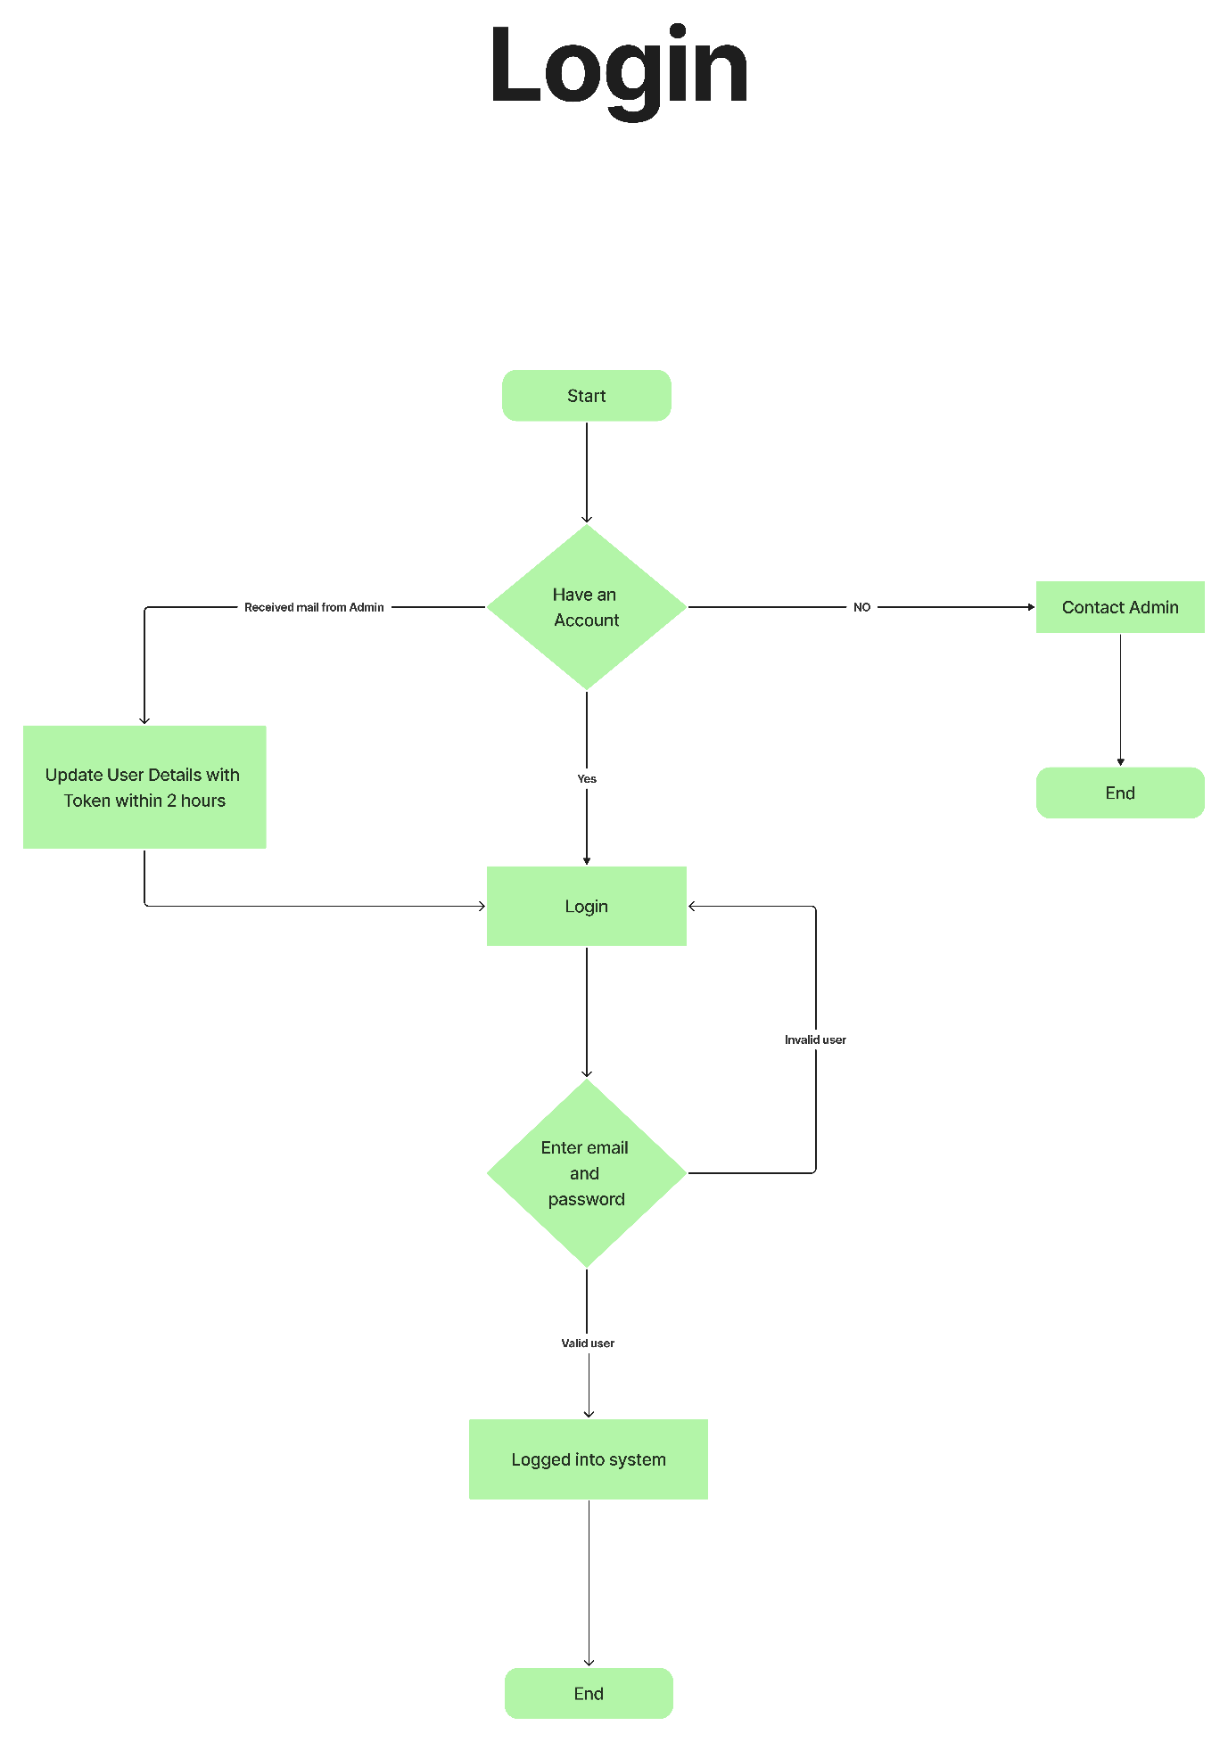

**Borrow Book**

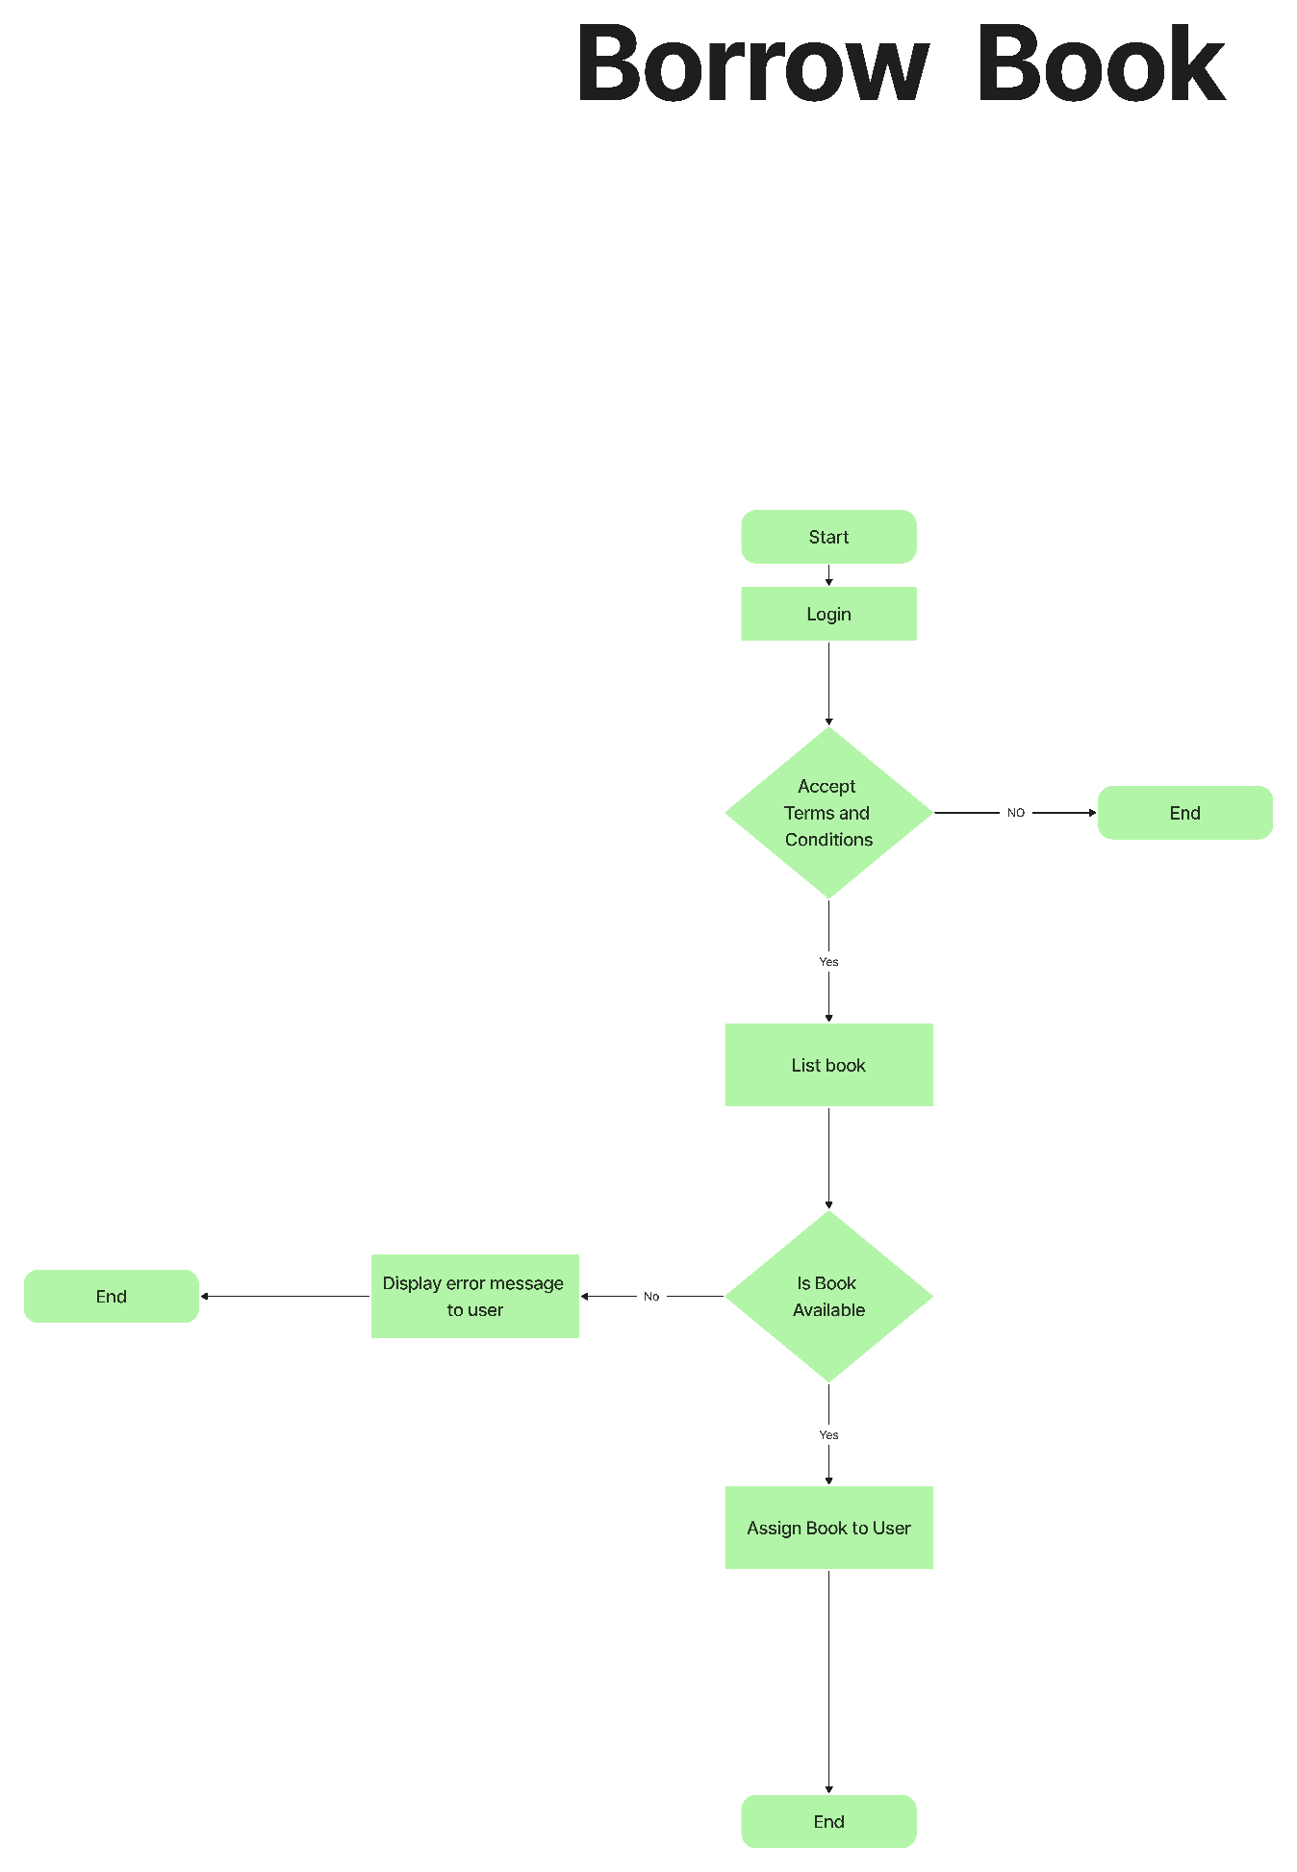

**Return Book**

